# **Name: Abdurrahman Qureshi**

# **Roll No: 210451**

Practical No: 10

1. **Write a Program to create a Login form for a social networking site. And do validation.**

**JAVA CODE:**

package com.example.mad_documentation;  
  
import android.support.v7.app.AppCompatActivity;  
import android.os.Bundle;  
import android.view.View;  
import android.widget.ArrayAdapter;  
import android.widget.AutoCompleteTextView;  
import android.widget.Button;  
import android.widget.EditText;  
import android.widget.TextView;  
import android.widget.Toast;  
  
public class MainActivity extends AppCompatActivity {  
  
 @Override  
 protected void onCreate(Bundle savedInstanceState) {  
 super.onCreate(savedInstanceState);  
 setContentView(R.layout.*activity_main*);  
 EditText nameField = (EditText) findViewById(R.id.*nameField*);  
 EditText passField = (EditText) findViewById(R.id.*passField*);  
 Button loginBtn = (Button) findViewById(R.id.*loginBtn*);  
  
 loginBtn.setOnClickListener(new View.OnClickListener() {  
 @Override  
 public void onClick(View view) {  
 String result;  
 if(*nameField*.getText().toString().equals("qarq90") && *passField*.getText().toString().equals("bich"))  
 result = "Successfully logged in (although there isn't anything to display.)";  
 else  
 result = "Incorrect username and/or password.";  
 Toast.*makeText*(getApplicationContext(), result, Toast.*LENGTH_LONG*).show();  
 }  
 });  
  
 }  
}

**XML CODE:**

<?xml version="1.0" encoding="utf-8"?>  
<LinearLayout xmlns:android="http://schemas.android.com/apk/res/android"  
 xmlns:app="http://schemas.android.com/apk/res-auto"  
 xmlns:tools="http://schemas.android.com/tools"  
 android:layout_width="match_parent"  
 android:layout_height="match_parent"  
 android:orientation="vertical"  
 android:padding="10dp"  
 android:gravity="center"  
 tools:context=".MainActivity">  
  
 <TextView  
 android:layout_width="match_parent"  
 android:layout_height="wrap_content"  
 android:text="Login"  
 android:textSize="50sp"  
 android:gravity="center"/>  
  
 <ImageView  
 android:layout_width="wrap_content"  
 android:layout_height="wrap_content"  
 android:layout_marginTop="-100dp"  
 android:src="@drawable/google_logo"  
 android:layout_marginBottom="50dp"/>  
  
 <EditText  
 android:id="@+id/nameField"  
 android:layout_width="match_parent"  
 android:layout_height="wrap_content"  
 android:hint="Username or email"  
 android:layout_marginTop="-100dp"  
 android:textSize="25sp"/>  
  
 <EditText  
 android:id="@+id/passField"  
 android:layout_width="match_parent"  
 android:layout_height="wrap_content"  
 android:hint="Password"  
 android:textSize="25sp"/>  
  
 <Button  
 android:id="@+id/loginBtn"  
 android:layout_width="match_parent"  
 android:layout_height="wrap_content"  
 android:text="LOG IN"  
 android:textSize="25sp"/>  
</LinearLayout>

**OUTPUT:**

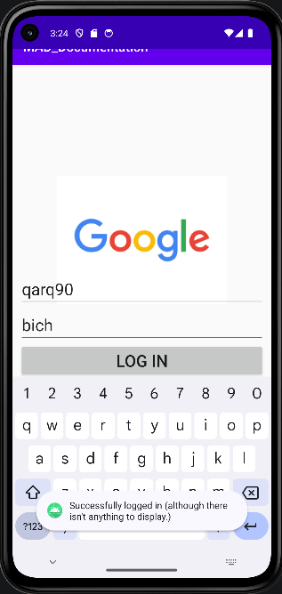

**2) Write a Program to create a Login form for student registration system.**

**CODE:**

<?xml version="1.0" encoding="utf-8"?>  
<LinearLayout xmlns:android="http://schemas.android.com/apk/res/android"  
 xmlns:app="http://schemas.android.com/apk/res-auto"  
 xmlns:tools="http://schemas.android.com/tools"  
 android:layout_width="match_parent"  
 android:layout_height="match_parent"  
 android:orientation="vertical"  
 android:padding="10dp"  
 tools:context=".MainActivity">  
  
 <TextView  
 android:layout_width="match_parent"  
 android:layout_height="wrap_content"  
 android:text="Student Registration"  
 android:textSize="40sp"  
 android:gravity="center"/>  
  
 <View  
 android:layout_width="match_parent"  
 android:layout_height="5dp"  
 android:background="@color/black"/>  
  
 <TextView  
 android:layout_width="match_parent"  
 android:layout_height="wrap_content"  
 android:text="Login"  
 android:layout_marginTop="100dp"  
 android:layout_marginBottom="50dp"  
 android:textSize="40sp"  
 android:gravity="center"/>  
  
 <EditText  
 android:id="@+id/nameField"  
 android:layout_width="match_parent"  
 android:layout_height="wrap_content"  
 android:hint="Student name"  
 android:textSize="25sp"/>  
  
 <EditText  
 android:id="@+id/passField"  
 android:layout_width="match_parent"  
 android:layout_height="wrap_content"  
 android:hint="Password"  
 android:textSize="25sp"/>  
  
 <Button  
 android:id="@+id/loginBtn"  
 android:layout_width="match_parent"  
 android:layout_height="wrap_content"  
 android:text="LOG IN"  
 android:layout_marginTop="40dp"  
 android:textSize="25sp"/>  
</LinearLayout>

**JAVA CODE:**  
package com.example.mad_documentation;  
  
import android.support.v7.app.AppCompatActivity;  
import android.os.Bundle;  
import android.view.View;  
import android.widget.ArrayAdapter;  
import android.widget.AutoCompleteTextView;  
import android.widget.Button;  
import android.widget.EditText;  
import android.widget.TextView;  
import android.widget.Toast;  
  
public class MainActivity extends AppCompatActivity {  
  
 @Override  
 protected void onCreate(Bundle savedInstanceState) {  
 super.onCreate(savedInstanceState);  
 setContentView(R.layout.*activity_main*);  
 EditText nameField = (EditText) findViewById(R.id.*nameField*);  
 EditText passField = (EditText) findViewById(R.id.*passField*);  
 Button loginBtn = (Button) findViewById(R.id.*loginBtn*);  
  
 loginBtn.setOnClickListener(new View.OnClickListener() {  
 @Override  
 public void onClick(View view) {  
 String result;  
 if(*nameField*.getText().toString().equals("qarq90") && *passField*.getText().toString().equals("bich"))  
 result = "Successfully logged in (although there isn't anything to display.)";  
 else  
 result = "Incorrect username and/or password.";  
 Toast.*makeText*(getApplicationContext(), result, Toast.*LENGTH_LONG*).show();  
 }  
 });  
 }  
}

**OUTPUT:**

